**PROJECT**

**DESIGN DOCUMENT**

**Team#1**

**DJ Cmar, Aaron Doyle, Celia Sanchez, Brice Sinack, Jacob Williams**

* **Title** – Sky High

* **Description/feature set** – Linear progression traversing a level while avoiding falling off and avoiding enemies.
* **Purpose/application** – The game is a form of entertainment to pass the time or for those who are looking to explore a unique setting. This is also a game for those who enjoy a minor challenge.
* **Premise/high concept** – Would you like fight your way across a unique setting in the clouds dodging and jumping? Well look no further!

* **Genre** – 2.5D Top Down Shooter/Platformer

* **Platform** – Primary platform will be PC. We will try to port the game to mobile (if applicable)

* **Audience/market** – Kids 8+, teens, adults. Anyone looking to casually play a game on a mobile market.
* **Rating** – E

* **Player mode** – Single player

* **Backstory/synopsis** – The player is dropped into the level suddenly and is surprised but quickly learns he/she is fighting to survive. The player must reach the end of the level avoid dying.

* **Character descriptions** – The player character will be a small model with fantasy attire there will be a choice between a male and female character.

* **Rules** – The player will traverse the level and they will earn points depending on enemies slain and the amount of time it took to complete the level as well as damage taken.
* **Challenges** – The player will have to be able fight enemies and dodge their attacks as well as avoid falling and traps. Each level will provide new challenges.

* **Strategies** – Prioritize avoiding damage over dealing damage.
* **Theory/game balance** – Enemies will be balanced accordingly, and the level layout will not hinder the player’s progression too much. For example faster enemies will only appear in a bigger area to allow the player to move around more. Also tougher enemies will show up later in the game when the player is ready.

* **Perspective/game view** – Top down camera following your avatar from directly above.

* **User interface** – Users will play the game with a keyboard and mouse if using a computer, and on screen keys when playing mobile (if applicable)
* **Audio** – There will be sound effects and ambient music playing throughout the game.

* **Summary/future updates** – Adding more level layouts, enemies and weapons to add more diversity.
* **Implementation Plan** – Pathfinding (Airdrops), Sensors (Turrets), Finite State Machines (Enemy AI), Flocks (Enemies that chase the player).
* **AI Implementations** –

**Pathfinding –** A flying beast will attack on a specific path, will try to find the most effective one for attacking the player.

**Finite State Machine –** Humanoids will attack the player and follow them according to built in FSM

**Sensors –** Turrets will attack the player and will track their movement

**Flocks/Crowds –** A flock of much smaller flying beasts will try to attack the player while traveling in a flock

* **Competitive analysis** – Enter the Gungeon, The Binding of Isaac Rebirth.
* **Prior Art** – From the studio that brought you Roamer and The Revenger.

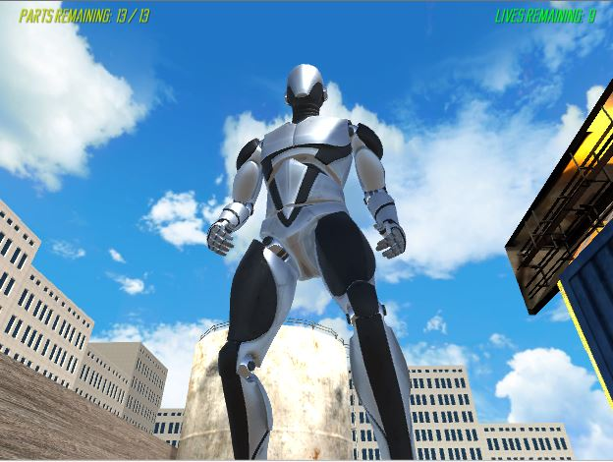

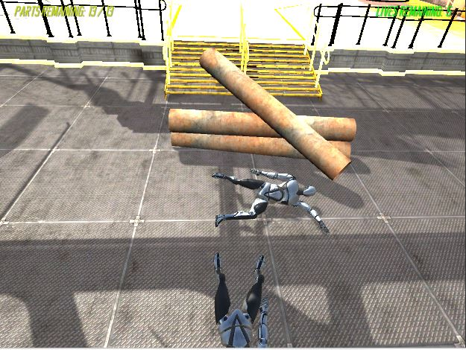

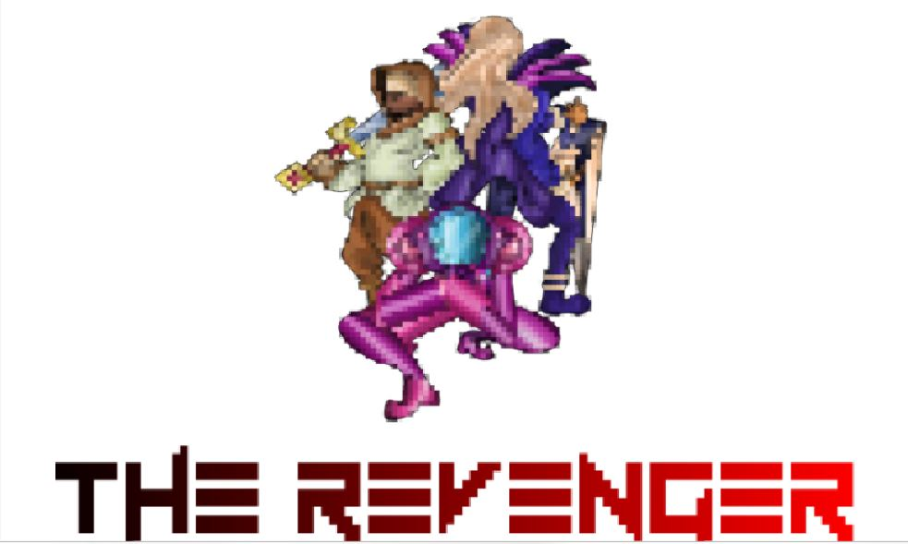

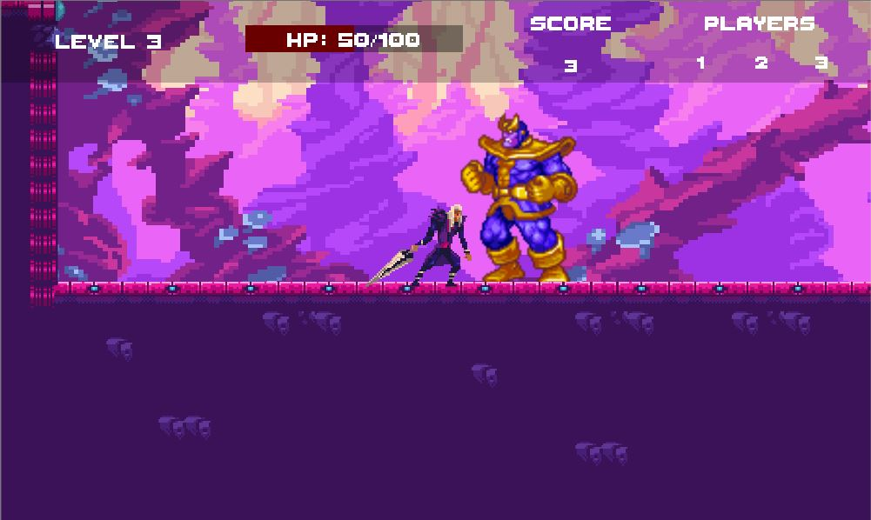

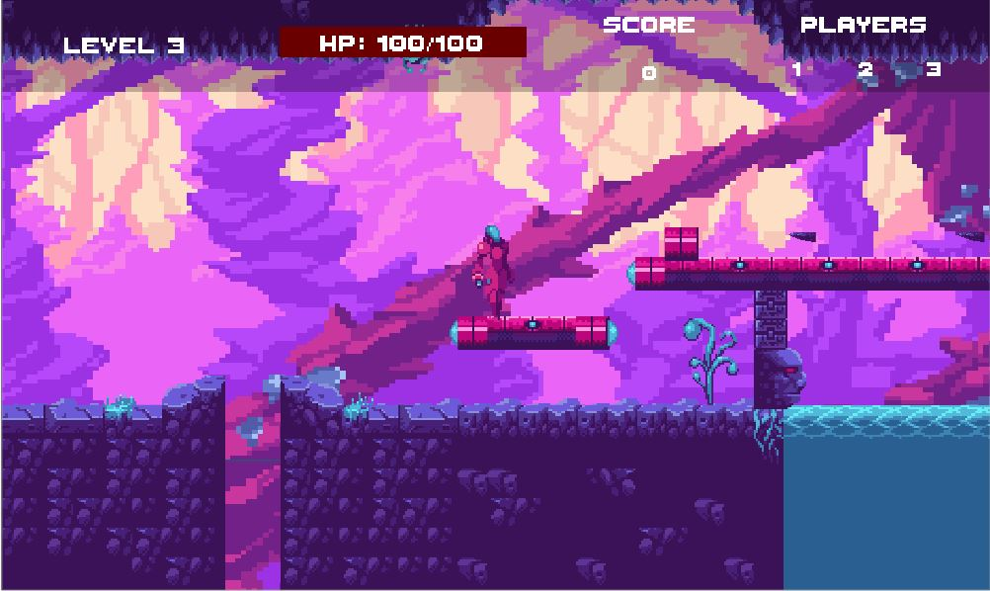

* **Marketing Plan** – Twitter and Facebook pages for our game, in addition to a website (coming soon)